**ASSIGNMENT 1**

**QUES 1**

#include <stdio.h>

#define SIZE 50

void create(int arr[],int n) {

int i;

printf("Enter %d elements:\n",n);

for(i=0;i<n;i++) {

scanf("%d",&arr[i]);

}

}

void display(int arr[],int n) {

int i;

printf("Array elements:\n");

for(i=0;i<n;i++) {

printf("%d ",arr[i]);

}

printf("\n");

}

void insert(int arr[],int *n,int element,int pos) {

int i;

if(pos<=0||pos>*n+1) {

printf("Invalid position!\n");

} else {

for(i=*n;i>=pos;i--) {

arr[i]=arr[i-1];

}

arr[pos-1]=element;

(*n)++;

}

}

void delete(int arr[],int *n,int pos) {

int i;

if(pos<=0||pos>*n) {

printf("Invalid position!\n");

} else {

for(i=pos-1;i<*n-1;i++) {

arr[i]=arr[i+1];

}

(*n)--;

}

}

int linearSearch(int arr[],int n,int element) {

int i;

for(i=0;i<n;i++) {

if(arr[i]==element) {

return i+1;

}

} return -1;

}

int main() {

int arr[SIZE];

int n=0,choice,element,pos;

do {

printf("\n----MENU----\n");

printf("1. Create\n2. Display\n3. Insert\n4. Delete\n5. Linear Search\n6. Exit\n");

printf("Enter your choice: ");

scanf("%d",&choice);

switch(choice) {

case 1:

printf("Enter the number of elements: ");

scanf("%d",&n);

create(arr,n);

break;

case 2:

display(arr,n);

break;

case 3:

printf("Enter element to be inserted: ");

scanf("%d",&element);

printf("Enter position: ");

scanf("%d",&pos);

insert(arr,&n,element,pos);

break;

case 4:

printf("Enter the position to delete: ");

scanf("%d",&pos);

delete(arr,&n,pos);

break;

case 5:

printf("Enter the element to search: ");

scanf("%d",&element);

pos=linearSearch(arr,n,element);

if(pos==-1) {

printf("Element not found!\n");

} else {

printf("Element found at position: %d\n",pos);

}

break;

case 6:

printf("Exiting the program\n");

break;

default:

printf("Invalid choice\n");

}

} while(choice!=6);

return 0;

}

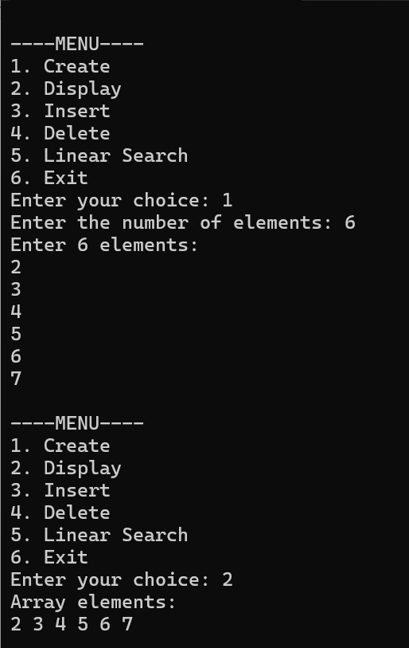 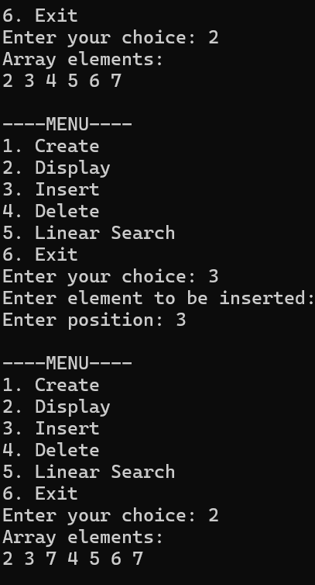

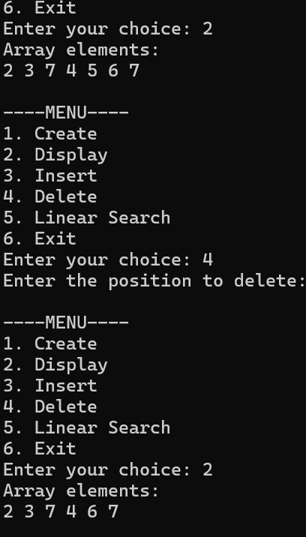 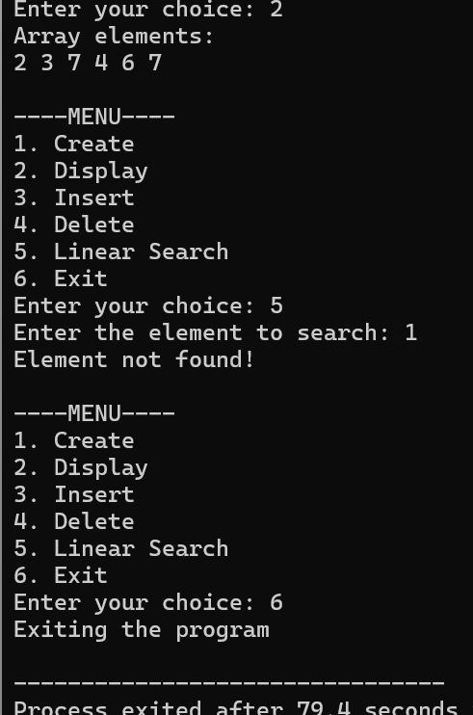

**QUES 2**

#include <stdio.h>

void removeDuplicates(int arr[],int *n) {

int temp[*n];

int i,j = 0,k;

for ( i =0;i <*n;i++) {

int duplicate = 0;

for (k =0; k<j; k++) {

if (arr[i] == temp[k]) {

duplicate = 1;

break;

}}

if (!duplicate) {

temp[j++] = arr[i];

} }

for ( i= 0; i<j; i++) {

arr[i] = temp[i];

}

*n = j;}

int main() {

int arr[50],n,i;

printf("Enter number of elements: ");

scanf("%d",&n);

printf("Enter the elements:\n");

for (i=0;i<n;i++) {

scanf("%d", &arr[i]);

}

removeDuplicates(arr, &n);

printf("Array after duplicate removal:\t");

for (i=0;i<n;i++) {

printf("%d \t",arr[i]);

}

return 0;

}

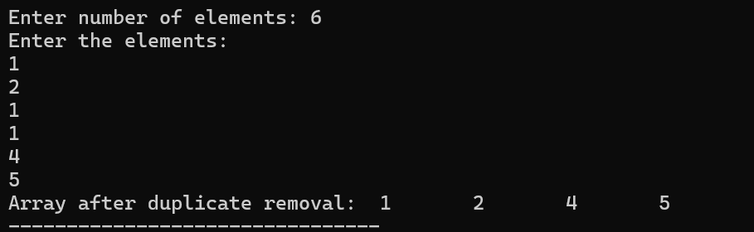

**QUES 3**

#include<stdio.h>

int main()

{

int i;

int arr[5] = {1};

for (i = 0; i < 5; i++)

printf("%d",arr[i]);

return 0;

}



**QUES 4**

1) #include <stdio.h>

int main() {

int arr[5],i ;

printf("Enter elements of array :");

for (i = 0; i < 5; i++) {

scanf("%d", &arr[i]);

}

printf("Original array is : ");

for (i = 0; i < 5; i++) {

printf("%d ", arr[i]);

}

printf("\n");

int start = 0;

int end = 4;

while (start < end) {

int temp = arr[start];

arr[start] = arr[end];

arr[end] = temp;

start++;

end--;

}

printf("Reversed array is : ");

for (i = 0; i < 5; i++) {

printf("%d ", arr[i]);

}

return 0;

}

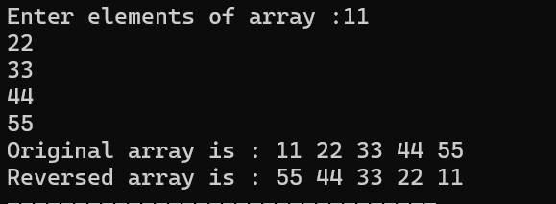

2) #include <stdio.h>

int main() {

int rows1,cols1,rows2,cols2;

printf("Enter the number of rows and columns of the first matrix: ");

scanf("%d %d",&rows1,&cols1);

printf("Enter the number of rows and columns of the second matrix: ");

scanf("%d %d",&rows2,&cols2);

if (cols1!=rows2) {

printf("Matrices cannot be multiplied. The columns in first matrix must be equal to the rows in second matrix.\n");

return 1;

}

int matrix1[rows1][cols1],matrix2[rows2][cols2],result[rows1][cols2];

printf("Enter the elements of the first matrix:\n");

for (int i=0;i<rows1;i++) {

for (int j=0;j<cols1;j++) {

scanf("%d",&matrix1[i][j]);

}

}

printf("Enter the elements of the second matrix:\n");

for (int i=0;i<rows2;i++) {

for (int j=0;j<cols2;j++) {

scanf("%d",&matrix2[i][j]);

}

}

for (int i=0;i<rows1;i++) {

for (int j=0;j<cols2;j++) {

result[i][j]=0;

for (int k =0;k < cols1;k++) {

result[i][j] += matrix1[i][k] * matrix2[k][j];

}

}

}

printf("Result matrix:\n");

for (int i=0;i< rows1;i++) {

for (int j = 0;j <cols2;j++) {

printf("%d ",result[i][j]);

}

printf("\n");

}

return 0;

}

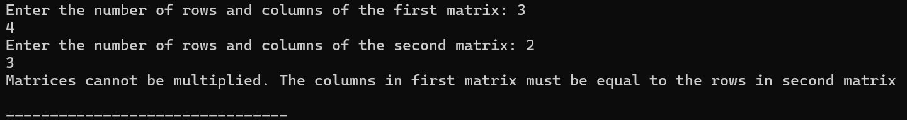

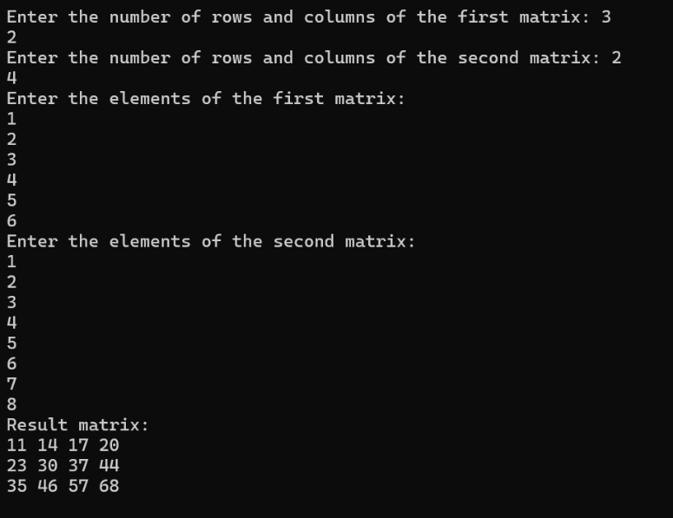

3) #include <stdio.h>

int main() {

int rows,cols;

printf("Enter the number of rows and columns of the matrix: ");

scanf("%d %d",&rows,&cols);

int matrix[rows][cols],transpose[cols][rows];

printf("Enter matrix elements:\n");

for (int i=0;i<rows;i++){

for (int j=0;j<cols;j++){

scanf("%d",&matrix[i][j]);

}

}

printf("Original matrix:\n");

for (int i=0;i<rows;i++) {

for (int j=0;j<cols;j++) {

printf("%d ",matrix[i][j]);

}

printf("\n");

}

for (int i=0;i<rows;i++){

for (int j=0;j<cols;j++){

transpose[j][i]=matrix[i][j];

}

}

printf("Transpose of the matrix:\n");

for (int i=0;i<cols;i++){

for (int j=0;j<rows;j++){

printf("%d ",transpose[i][j]);

}

printf("\n");

}

return 0;

}

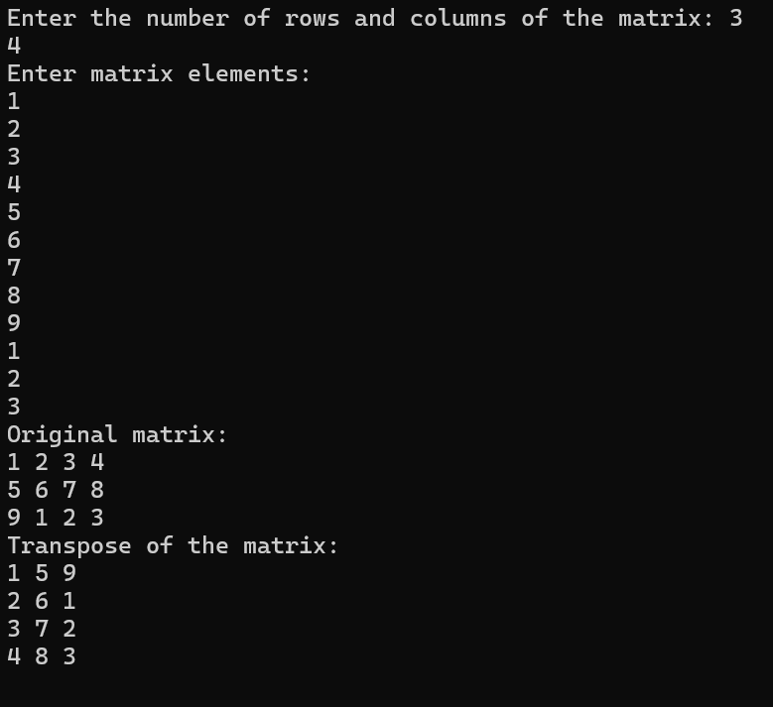

**QUES 5**

#include <stdio.h>

int main() {

int rows, cols;

printf("Enter the number of rows and columns: ");

scanf("%d %d", &rows, &cols);

int matrix[rows][cols];

printf("Enter the elements of the matrix:\n");

for (int i = 0; i < rows; i++) {

for (int j = 0; j < cols; j++) {

scanf("%d", &matrix[i][j]);

}

}

int rowSums[rows];

for (int i = 0; i < rows; i++) {

rowSums[i] = 0;

for (int j = 0; j < cols; j++) {

rowSums[i] += matrix[i][j];

}

}

int colSums[cols];

for (int j = 0; j < cols; j++) {

colSums[j] = 0;

for (int i = 0; i < rows; i++) {

colSums[j] += matrix[i][j];

}

}

printf("Row sums:\n");

for (int i = 0; i < rows; i++) {

printf("%d ", rowSums[i]);

}

printf("\n");

printf("Column sums:\n");

for (int j = 0; j < cols; j++) {

printf("%d ", colSums[j]);

}

printf("\n");

return 0;

}

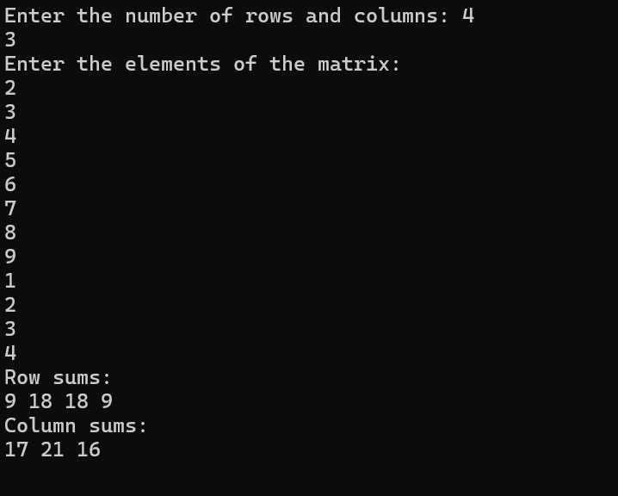



***Name: Nishant Bimra..***